FORM 2 MIDTERM 2 EXAMS


ALL SUBJECTS

Compilation of Standard series of Mid-Term 2 Examinations for
the Current Class for all High Schools in the Republic of Kenya.

SUBJECTS COMPILED;
Mathematics, English, Kiswahili, Biology, Chemistry, Physics, CRE, Geography, History, Business Studies & Agriculture.

SERIES 1

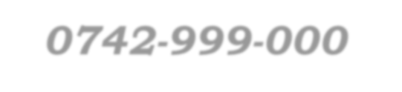
For Marking Schemes / Answers
Mr Isaboke 0746-222-000 / 0742-999-000
MWALIMU CONSULTANCY

FORM 2 MIDTERM 2 EXAMS

SERIES 1
GEOGRAPHY
TIME: 2 HOURS

NAME……………………………………………………. ADM NO; …………………..

CLASS……………………………………………………… DATE……………………..

1 (a) What is an eclipse? (2mks)
………………………………………………………………………………………………………
………………………………………………………………………………………………………
(b) State the characteristics of the earth’s core (4mks)
………………………………………………………………………………………………………
………………………………………………………………………………………………………
………………………………………………………………………………………………………
………………………………………………………………………………………………………

- The diagram below shows the structure of the earth. Use it to answer question(a)

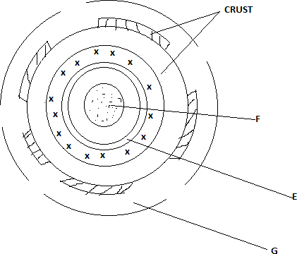

- Name the parts marked E,F and G (3mks)
………………………………………………………………………………………………………
………………………………………………………………………………………………………
………………………………………………………………………………………………………

- State four characteristics of the part labeled G. (4mks)
………………………………………………………………………………………………………
………………………………………………………………………………………………………
………………………………………………………………………………………………………
………………………………………………………………………………………………………

- (a) Identify three forms of rock metamorphism. (3mks)
………………………………………………………………………………………………………
………………………………………………………………………………………………………
………………………………………………………………………………………………………

- State the extrusive equivalent of earth of the following intrusive igneous rocks (3mks)
  - Granite
  - Diorite
  - Gabbro

- (a) What is a seismic wave? (2mks)
………………………………………………………………………………………………………
………………………………………………………………………………………………………

(b) State 4 ways in which earthquake affects human activities (4mks)
………………………………………………………………………………………………………
………………………………………………………………………………………………………
………………………………………………………………………………………………………
………………………………………………………………………………………………………

- (a) Differentiate between fissure and vent eruption (2mks)
………………………………………………………………………………………………………
………………………………………………………………………………………………………
- Describe how the following features are formed
  - Batholiths (6mks)
………………………………………………………………………………………………………
………………………………………………………………………………………………………
………………………………………………………………………………………………………
………………………………………………………………………………………………………
………………………………………………………………………………………………………
………………………………………………………………………………………………………
………………………………………………………………………………………………………
………………………………………………………………………………………………………

  - Volcanic plug (5mks)
………………………………………………………………………………………………………
………………………………………………………………………………………………………
………………………………………………………………………………………………………
………………………………………………………………………………………………………
………………………………………………………………………………………………………
………………………………………………………………………………………………………

- Explain 4 negative effects of Volcanicity on human activities (8mks)
………………………………………………………………………………………………………
………………………………………………………………………………………………………
………………………………………………………………………………………………………
………………………………………………………………………………………………………
………………………………………………………………………………………………………
………………………………………………………………………………………………………
………………………………………………………………………………………………………
………………………………………………………………………………………………………
………………………………………………………………………………………………………

- You are planning to carry out a field study on features formed by volcanicity on the landscape
- Formulate two null hypotheses (2mks)
………………………………………………………………………………………………………
………………………………………………………………………………………………………
………………………………………………………………………………………………………

- Name two drainage features you are likely to study (2mks)
………………………………………………………………………………………………………
………………………………………………………………………………………………………
………………………………………………………………………………………………………

- (a) State four ways in which minerals occur (4mks)
………………………………………………………………………………………………………
………………………………………………………………………………………………………
………………………………………………………………………………………………………
………………………………………………………………………………………………………

(b)(i)Other than shaft method name two other underground methods of mining (2mks)
………………………………………………………………………………………………………
………………………………………………………………………………………………………
………………………………………………………………………………………………………

(ii) Kenya recently discovered petroleum in Ngamia II Turkana. State five positive effects that Kenya is likely to benefit from (5mks)
………………………………………………………………………………………………………
………………………………………………………………………………………………………
………………………………………………………………………………………………………
………………………………………………………………………………………………………
………………………………………………………………………………………………………
………………………………………………………………………………………………………

- Explain four ways in which Kenya has benefited from the mining of soda ash from Lake Magadi (8mks)
………………………………………………………………………………………………………
………………………………………………………………………………………………………
………………………………………………………………………………………………………
………………………………………………………………………………………………………
………………………………………………………………………………………………………
………………………………………………………………………………………………………
………………………………………………………………………………………………………
………………………………………………………………………………………………………
………………………………………………………………………………………………………

- State six adverse effects of gold mining to the environment of South Africa (6mks)
………………………………………………………………………………………………………
………………………………………………………………………………………………………
………………………………………………………………………………………………………
………………………………………………………………………………………………………
………………………………………………………………………………………………………
………………………………………………………………………………………………………
………………………………………………………………………………………………………
………………………………………………………………………………………………………

FORM 2 MIDTERM 2 EXAMS

SERIES 1
HISTORY AND GOVERNMENT
TIME: 2 HOURS

NAME……………………………………………………. ADM NO; …………………..

CLASS……………………………………………………… DATE……………………..

SECTION A (25MKS)

Answer all questions in this section.

1. Defines the government. | (2mks)
2. Name two oral sources of information on history and government. | (2mks)
3. Define the term citizenship. | (2mks)
4. Identify two main methods of trade. | (2mks)
5. Name the first deputy chief justice under the new constitution. | (1mk)
6. Name the highest court in Kenya today. | (1mk)
7. Name two groups of the Luo who migrated and settled into Kenya. | (2mks)
- State two causes of Bukusu résistance during the establishment of colonial rule in Kenya.(2mks)
- Name two Christian missionaries at work in Kenya by the19th century . (2mks) 10 .Give one environmental reason for the migration of Cushites into Kenya. (1mk)
- How many constituencies do we have in Kenya? (1mk}
- Apart from Fort Ternan, name two other sites in Kenya where Kenyapithecus was discovered.
(2mks)
- Identify two groups of people that comprise the Eastern Cushitic speakers in Kenya. (2mks)
- Name the two deputies prime minister in the coalition government. (2mks)
- Who is the last minister of sports and youth affairs in the coalition? (1mk)

SECTION B (45MKS)

Answer any THREE questions.
- (a) What factors influenced the growth of Nairobi? (5mks)
(b)Discuss the problems facing Nairobi. (10mks)

- (a) Describe the economic organization of the Nandi during the pre-colonial period. (5mks)
(b)Explain the functions of the Orkoiyot among the Nandi up to the 17th century (10mks)

- (a)State THREE factors which facilitated the spread of Islam in East Africa. (3mks)
(b)Explain the factors that contributed to the growth and rise of Coastal city States. (12mks)

- (a) State THREE political parties that are members of the Coalition of Reforms and Democracy
(3mks)
- Explain the achievements of the coalition government. (12mks)

SECTION C (30mks)

Answer any TWO questions.
- (a) State THREE symbols of National unity. (3mks)
(b) Discuss SIX factors that promote National unity. (12mks)

- (a) Mention FIVE factors promoting National integration. (5mks)
  - Classify and discuss human rights. (10mks)

- (a)State features of Macadam Roads. (5mks)
(b) Explain the advantages of road transport. (10mks)

FORM 2 MIDTERM 2 EXAMS

SERIES 1
BIOLOGY
TIME: 2 HOURS

NAME……………………………………………………. ADM NO; …………………..

CLASS……………………………………………………… DATE……………………..

INSTRUCTIONS TO STUDENTS
    - Answer all questions in this question paper.
    - All your answers must be written in the spaces provided in this question paper.

- The diagram below represents a plant cell organelle
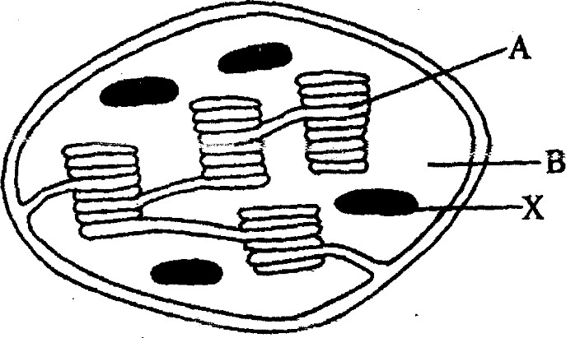
  - Name the organelle. (1mk)
………………………………………………………………………………………………………

  - In which of the labelled parts does carbon (IV) Oxide fixation occur? (1mk)

  - Name the parts labelled A and B and state how each is adapted to its functions. (4mks) A............................................................................................................................................................
B............................................................................................................................................................

  - Explain what would have happened to the structures labelled X had the plant been kept in darkness for 48 hours. (2mks)

- The diagram below shows some components of a light microscope.
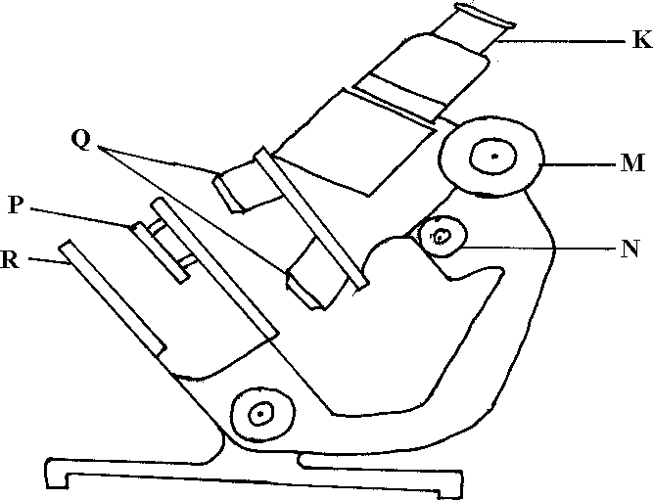

Name the parts labeled (2mrks)
K ………………………………………………………………………………………………
M ………………………………………………………………………………………………

- State the functions of (2mrks)
P ………………………………………………………………………………………………
Q ………………………………………………………………………………………………

- A student was viewing a prepared slide of a plant cell under high power microscope. The features of the cell were blurred. Which one of the labelled parts of the microscope would the student use to obtain:-
- a sharper outline of the features. (1mrk)
………………………………………………………………………………………………

- Give the formula used to calculate magnification in a light microscope. (1mrk)
………………………………………………………………………………………………

- A student was preparing a section of a plant cell to be viewed on a light microscope. Give a reason for each of the following steps:-
- Cutting a very thin section (1mrk)

- Staining the section (1mrk)

- Putting the section in water (1mrk)

- The diagram below shows part of a longitudinal section of a root: -
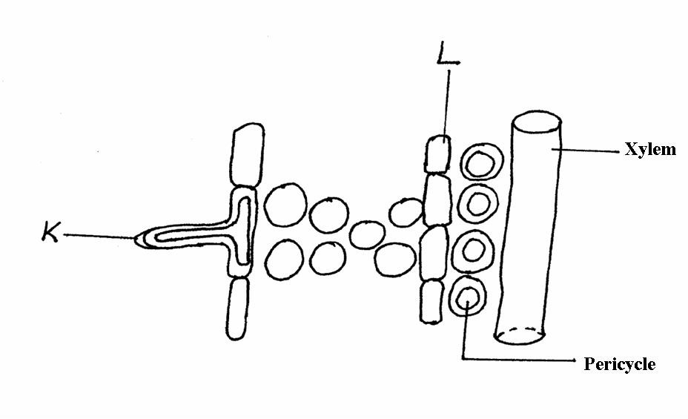

- Identify cells K and L :- (2 mks)
K
……………………………………………………………………………………………………….
L
……………………………………………………………………………………………………….

- State two adaptations of Cell K to its functions :- (2 mks)
………………………………………………………………………………………………………
………………………………………………………………………………………………………
………………………………………………………………………………………………………

- State three main functions of the stomach in human beings:- (3 mks)
………………………………………………………………………………………………………
………………………………………………………………………………………………………
………………………………………………………………………………………………………

- Name the cell organelles responsible for :
- Protein synthesis
- Destroying worn – out organells and cells

6.a)Lietego school biology student used a microscope with x40 objective lens and x5 eye piece lens which had 2mm radius. Calculate the area of the field of view in micrometers. (2mks)

  - What is the average size of the cell in micrometers (2mks)

7.(a) Identify the organelle shown below:- (1mk)
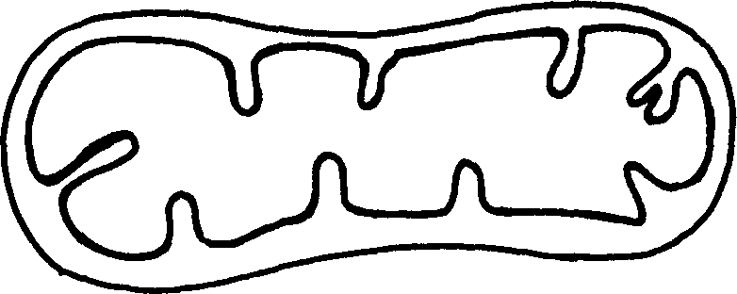

(b) How is the organelle you have identified in (a) above suited to its function (2mks)
………………………………………………………………………………………………………
………………………………………………………………………………………………………
………………………………………………………………………………………………………

8. State three properties of the cell membrane (3mks)
………………………………………………………………………………………………………
………………………………………………………………………………………………………
………………………………………………………………………………………………………

9.a) What is the formula for calculating linear magnification of a specimen when using a
hand lens (1mk)
………………………………………………………………………………………………………
………………………………………………………………………………………………………

- Distinguish between the following terms :- (4mks)
Magnification and resolution of a microscope
………………………………………………………………………………………………………
………………………………………………………………………………………………………
………………………………………………………………………………………………………

Mounting and staining of a specimen
………………………………………………………………………………………………………
………………………………………………………………………………………………………
………………………………………………………………………………………………………

- Name the organelle that performs each of the following functions in a cell. (3mks)
- Transport of packaged glycoproteins

- Destruction of worn out cell organelles

- Synthesis of proteins

- Why are the following procedures done when preparing sections to be observed under a light microscope? (3mks
- Making of thin sections

- Using a sharp blade to make the sections

  - Staining

- State three physiological processes that are involved in movement of substances a cross the cell membrane (3mks)
………………………………………………………………………………………………………
………………………………………………………………………………………………………
………………………………………………………………………………………………………

- Name the diseases caused by deficiency of : (2mks)
- Iodine

- Vitamin C

- What are the two functions of bile salts during the process of digestion? (2mks)

………………………………………………………………………………………………………
………………………………………………………………………………………………………

- State two adaptations of herbivores which enable them to digest cellulose (2mks)
………………………………………………………………………………………………………
………………………………………………………………………………………………………
………………………………………………………………………………………………………

- State three factors that affect the rate of osmosis (3mks)
………………………………………………………………………………………………………
………………………………………………………………………………………………………
………………………………………………………………………………………………………

- State three roles of light in photosynthesis (3mks)
………………………………………………………………………………………………………
………………………………………………………………………………………………………
………………………………………………………………………………………………………

- Explain how saliva is important in digestion (2mks)
………………………………………………………………………………………………………
………………………………………………………………………………………………………
………………………………………………………………………………………………………

- Briefly explain the fate of the following products from the light stage of the process of Photosynthesis (3mks)
(a) Oxygen
………………………………………………………………………………………………………
………………………………………………………………………………………………………
b)Hydrogen
………………………………………………………………………………………………………
………………………………………………………………………………………………………
(c) ATP
………………………………………………………………………………………………………
………………………………………………………………………………………………………

- State three ways by which plants compensate for lack of the ability to move from one place to another(3mks)
………………………………………………………………………………………………………
………………………………………………………………………………………………………
………………………………………………………………………………………………………

21. State four difference between monosaccharide and polysaccharides (4mks)
………………………………………………………………………………………………………
………………………………………………………………………………………………………
………………………………………………………………………………………………………
………………………………………………………………………………………………………
………………………………………………………………………………………………………

- Describe how mammalian small intestine is adapted to its function (7mks)
………………………………………………………………………………………………………
………………………………………………………………………………………………………
………………………………………………………………………………………………………
………………………………………………………………………………………………………
………………………………………………………………………………………………………
………………………………………………………………………………………………………
………………………………………………………………………………………………………
………………………………………………………………………………………………………
………………………………………………………………………………………………………
………………………………………………………………………………………………………

FORM 2 MIDTERM 2 EXAMS

SERIES 1
AGRICULTURE
TIME: 2 HOURS

NAME……………………………………………………. ADM NO; …………………..

CLASS……………………………………………………… DATE……………………..

INSTRUCTIONS TO STUDENTS
  - Answer all questions in this question paper.
  - All your answers must be written in the spaces provided in this question paper.

Answer All the Questions
- List four characteristics of plantation farming (4mks)
………………………………………………………………………………………………………
………………………………………………………………………………………………………
………………………………………………………………………………………………………
………………………………………………………………………………………………………

- Give four benefits of Agro forestry (4mks)
………………………………………………………………………………………………………
………………………………………………………………………………………………………
………………………………………………………………………………………………………
………………………………………………………………………………………………………

- Differentiate between soil structure and soil texture (2mks)
………………………………………………………………………………………………………
………………………………………………………………………………………………………
………………………………………………………………………………………………………

- State four reasons for treating water in the farm (4mks)
………………………………………………………………………………………………………
………………………………………………………………………………………………………
………………………………………………………………………………………………………
………………………………………………………………………………………………………

- State four disadvantages of using organic manure (4mks)
………………………………………………………………………………………………………
………………………………………………………………………………………………………
………………………………………………………………………………………………………
………………………………………………………………………………………………………

- Name two species of camel (2mks)
………………………………………………………………………………………………………
………………………………………………………………………………………………………

- State four control measures of tsetse flies (4mks)
………………………………………………………………………………………………………
………………………………………………………………………………………………………
………………………………………………………………………………………………………
………………………………………………………………………………………………………

- What is meant by BosInducus? (1mk)
………………………………………………………………………………………………………
………………………………………………………………………………………………………

- Name four dairy breeds of goat (4mks)
………………………………………………………………………………………………………
………………………………………………………………………………………………………
………………………………………………………………………………………………………
………………………………………………………………………………………………………

- Why do we keep farm record (1mk)
………………………………………………………………………………………………………
………………………………………………………………………………………………………

SECTION B (20 MKS)
- The diagram below illustrates some types of soil structure. Study and answer the question that follow
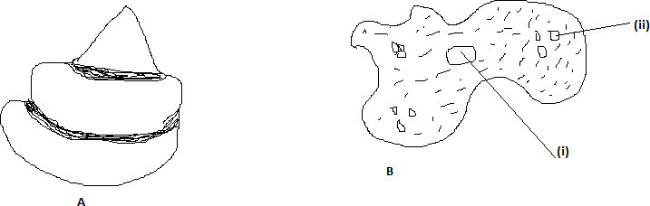

- Identify the type of soil structure illustrated by (2mks) A

B

- Name parts labeled (i) and (ii) (2mks)
………………………………………………………………………………………………………
………………………………………………………………………………………………………

- State two effects of soil structure A in crop production (2mks)
………………………………………………………………………………………………………
………………………………………………………………………………………………………
………………………………………………………………………………………………………
………………………………………………………………………………………………………

- Below are farm tools

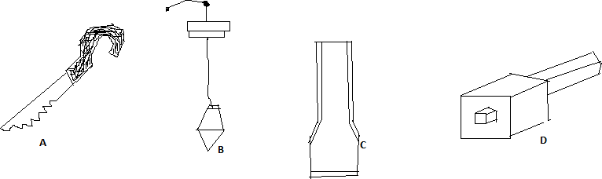

- Name the tool above (4mks)
A B C D

b) State use of each tool above (4mks)
A B C D

  - State two maintenance that can be carried to tool D (2mk)
………………………………………………………………………………………………………
………………………………………………………………………………………………………
………………………………………………………………………………………………………

  - Classify the following tools at their appropriate categories (4mks)

Categories
A
B
C
D

SECTION C (40 MKS)
- (a) State the importance of livestock in the farm (4mks)
………………………………………………………………………………………………………
………………………………………………………………………………………………………
………………………………………………………………………………………………………
………………………………………………………………………………………………………
………………………………………………………………………………………………………

- Explain differences between BosIndicus and Bos Taurus breeds (10mks)
………………………………………………………………………………………………………
………………………………………………………………………………………………………
………………………………………………………………………………………………………
………………………………………………………………………………………………………
………………………………………………………………………………………………………
………………………………………………………………………………………………………
………………………………………………………………………………………………………
………………………………………………………………………………………………………
………………………………………………………………………………………………………
………………………………………………………………………………………………………
………………………………………………………………………………………………………

- List six breeds of rabbit (6mks)
………………………………………………………………………………………………………
………………………………………………………………………………………………………
………………………………………………………………………………………………………
………………………………………………………………………………………………………
………………………………………………………………………………………………………
………………………………………………………………………………………………………

- (a) Describe the importance of livestock husbandly (15mks)
………………………………………………………………………………………………………
………………………………………………………………………………………………………
………………………………………………………………………………………………………
………………………………………………………………………………………………………
………………………………………………………………………………………………………
………………………………………………………………………………………………………
………………………………………………………………………………………………………
………………………………………………………………………………………………………
………………………………………………………………………………………………………
………………………………………………………………………………………………………
………………………………………………………………………………………………………
………………………………………………………………………………………………………
………………………………………………………………………………………………………
………………………………………………………………………………………………………
………………………………………………………………………………………………………
………………………………………………………………………………………………………

- State four breeds of dairy cattles (4mks)
………………………………………………………………………………………………………

- Which dairy breeds produce high butter fat content
………………………………………………………………………………………………………
………………………………………………………………………………………………………

15 (a) Discuss seven method by which soil is able to loss its fertility (14mks)
………………………………………………………………………………………………………
………………………………………………………………………………………………………
………………………………………………………………………………………………………
………………………………………………………………………………………………………
………………………………………………………………………………………………………
………………………………………………………………………………………………………
………………………………………………………………………………………………………
………………………………………………………………………………………………………
………………………………………………………………………………………………………
………………………………………………………………………………………………………
………………………………………………………………………………………………………
………………………………………………………………………………………………………
………………………………………………………………………………………………………
………………………………………………………………………………………………………
………………………………………………………………………………………………………
………………………………………………………………………………………………………

(b) State six characteristic of a fertile soil (6mks)
………………………………………………………………………………………………………
………………………………………………………………………………………………………
………………………………………………………………………………………………………
………………………………………………………………………………………………………
………………………………………………………………………………………………………
………………………………………………………………………………………………………

FORM 2 MIDTERM 2 EXAMS

SERIES 1
BUSINESS STUDIES
TIME: 2 HOURS

NAME……………………………………………………. ADM NO; …………………..

CLASS……………………………………………………… DATE……………………..

- State FOUR roles of entrepreneurship in the society (4mks)
………………………………………………………………………………………………………
………………………………………………………………………………………………………
………………………………………………………………………………………………………
………………………………………………………………………………………………………

- Classify the factors listed in the table below as either internal or external. (tick appropriately)

Factors | Internal | External
(i) Employees
(ii) Inflation
(iii) Technology applied
(iv) Invested funds
(v) Cultural factors
(vi) Tools
(vii) Entrepreneur
(viii) Political factors
- State FOUR personal attributes that an office worker should possess. (4mks)

- State FOUR ways through which government control businesses. (4mks)
………………………………………………………………………………………………………
………………………………………………………………………………………………………
………………………………………………………………………………………………………
………………………………………………………………………………………………………

- State FOUR factors that a consumer should consider in satisfying competing needs. (4mks)
………………………………………………………………………………………………………
………………………………………………………………………………………………………
………………………………………………………………………………………………………
………………………………………………………………………………………………………

- State FOUR ways through which organizations can improve efficiency of their workers.
(4mks)
………………………………………………………………………………………………………
………………………………………………………………………………………………………
………………………………………………………………………………………………………
………………………………………………………………………………………………………

- State four FACTORS that can to the success of a business. (4mks)
………………………………………………………………………………………………………
………………………………………………………………………………………………………
………………………………………………………………………………………………………
………………………………………………………………………………………………………

- State FOUR advantages of indirect production. (4mks)
………………………………………………………………………………………………………
………………………………………………………………………………………………………
………………………………………………………………………………………………………
………………………………………………………………………………………………………

- Mention FOUR demerits of using middle-men in distribution of goods and services. (4mks)
………………………………………………………………………………………………………
………………………………………………………………………………………………………
………………………………………………………………………………………………………
………………………………………………………………………………………………………
………………………………………………………………………………………………………

- State FOUR advantages of buying goods on credit over hire purchase buying. (4mks)
………………………………………………………………………………………………………
………………………………………………………………………………………………………
………………………………………………………………………………………………………
………………………………………………………………………………………………………

- List FOUR factors to consider before choosing the type of business to start. (4mks)
………………………………………………………………………………………………………
………………………………………………………………………………………………………
………………………………………………………………………………………………………
………………………………………………………………………………………………………

- State FOUR ways used by organizations to safeguard and protect its property. (4mks)
………………………………………………………………………………………………………
………………………………………………………………………………………………………
………………………………………………………………………………………………………
………………………………………………………………………………………………………
………………………………………………………………………………………………………

- State FOUR macro-environment factors that affect business performance. (4mks)

- State any FOUR government initiated methods of consumer protection. (4mks)
………………………………………………………………………………………………………
………………………………………………………………………………………………………
………………………………………………………………………………………………………
………………………………………………………………………………………………………

- Explain any FOUR circumstances a buyer may be required to pay cash with order. (4mks)
………………………………………………………………………………………………………
………………………………………………………………………………………………………
………………………………………………………………………………………………………
………………………………………………………………………………………………………
………………………………………………………………………………………………………
………………………………………………………………………………………………………

- State any FOUR limitations of consumer initiated methods of consumer protection. (4mks)
………………………………………………………………………………………………………
………………………………………………………………………………………………………
………………………………………………………………………………………………………
………………………………………………………………………………………………………

- Give FOUR reasons why an office is necessary in an organization. (4mks)
………………………………………………………………………………………………………
………………………………………………………………………………………………………
………………………………………………………………………………………………………
………………………………………………………………………………………………………

- State FOUR benefits of business ethics. (4mks)
………………………………………………………………………………………………………
………………………………………………………………………………………………………
………………………………………………………………………………………………………
………………………………………………………………………………………………………

- Mention FOUR features of a sole trader. (4mks)
………………………………………………………………………………………………………
………………………………………………………………………………………………………
………………………………………………………………………………………………………
………………………………………………………………………………………………………

- Highlight FOUR causes of business failure. (4mks)
………………………………………………………………………………………………………
………………………………………………………………………………………………………
………………………………………………………………………………………………………
………………………………………………………………………………………………………

- Give four reasons why a cheque may be dishonored by a bank. (4mks)
………………………………………………………………………………………………………
………………………………………………………………………………………………………
………………………………………………………………………………………………………
………………………………………………………………………………………………………
………………………………………………………………………………………………………

- A trader gives 20% trade discount on the value of goods bought above and also a cash discount 10% if payments are made within one week. Onyango bought goods from the trader on the credit worth 200,000 on 3rd match 2013 and settled his debts on 8th of the same month. Find how much he paid. (4mks)

- Mention FOUR characteristics of services. (4mks)
………………………………………………………………………………………………………
………………………………………………………………………………………………………
………………………………………………………………………………………………………
………………………………………………………………………………………………………
………………………………………………………………………………………………………

- Highlight FOUR circumstances where a trader may issue a credit note. (4mks)
………………………………………………………………………………………………………
………………………………………………………………………………………………………
………………………………………………………………………………………………………
………………………………………………………………………………………………………
………………………………………………………………………………………………………
………………………………………………………………………………………………………

FORM 2 MIDTERM 2 EXAMS

SERIES 1
CHEMISTRY
TIME: 2 HOURS

NAME……………………………………………………. ADM NO; …………………..

CLASS……………………………………………………… DATE……………………..

INSTRUCTIONS TO STUDENTS
  - Answer all questions in this question paper.
  - All your answers must be written in the spaces provided in this question paper.

1((a). The table below shows some properties of chlorine, bromine and iodine .
element | formula | olour and state room  temperature | Solubility in water
Chlorine | Cl₂ | (i) | Soluble
Bromine | Br₂ | Brown liquid | (ii)
iodine | I2 | (iii) | Slightly soluble

Complete the table by giving the missing information in (i), (ii) and (iii) above. (3mks) (b). Chlorine gas is prepared by reacting concentrated hydrochloric acid with either Manganese
(IV) oxide or Potassium permanganate.
- Write the equation for the reaction between concentrated hydrochloric acid and Manganese (IV) oxide. (1mk)
…………………………………………………………………………………………………………
…………………………………………………………………………………………………………

- What is the role of manganese (iv) oxide in this reaction? (1mk)
…………………………………………………………………………………………………………

- When potassium permanganate is used instead of manganese (iv) oxide, heating is not required. Explain. (1mk)
…………………………………………………………………………………………………………
…………………………………………………………………………………………………………

- Give two advantages of using potassium permanganate over manganese (IV) oxide. (2mks)
…………………………………………………………………………………………………………
…………………………………………………………………………………………………………

- Iron metal reacts with chlorine to form substance E. identify substance E. (1mk)
…………………………………………………………………………………………………………
…………………………………………………………………………………………………………

- Write a chemical equation to represent the reaction in (V) above. (1mk)
…………………………………………………………………………………………………………
…………………………………………………………………………………………………………

(c). The set up below was used to collect gas F produced between water and calcium metal.

beaker
Gas F
Test tube

Calcium metal

- Name gas F. (1mk)
…………………………………………………………………………………………………………
- Write an equation for the production of gas F. (1mk).
…………………………………………………………………………………………………………
…………………………………………………………………………………………………………

- At the end of the experiment, the solution in the beaker was found to be a weak base. Explain why the solution was a weak base. (2mks)
…………………………………………………………………………………………………………
…………………………………………………………………………………………………………

- Give one laboratory use of the solution formed in the beaker. (1mk)
…………………………………………………………………………………………………………
…………………………………………………………………………………………………………

2(a). The set op below was used to investigate the reaction of sodium metal with chlorine gas. Study it and answer the questions that follow.

Deflagrating spoon Chlorine gas
Warm piece of sodium metal

- State two observations that would be made in the gas jar. (2mks)
…………………………………………………………………………………………………………
…………………………………………………………………………………………………………

- Write an equation for the reaction that occurred. (1mk)
…………………………………………………………………………………………………………
…………………………………………………………………………………………………………

(b). In an experiment , dry hydrogen gas was passed over heated lead (II) oxide as shown below.

Lead (II) oxide

Dry hydrogen gas

Heat

- State the two observations made in the combustion tube after the experiment. (2mks)
…………………………………………………………………………………………………………
…………………………………………………………………………………………………………

- Write a chemical equation for the reaction that occurred in the combustion tube. (1mk)
…………………………………………………………………………………………………………

- What property of hydrogen gas is shown by the reaction in b (ii) above? (1mk)
…………………………………………………………………………………………………………
…………………………………………………………………………………………………………

  - In an experiment, a test tube of chlorine gas was inverted in water as shown in the diagram. It was then left to stand in sunlight for one day.

sunlight

Chlorine water Gas M

Test tube

After one day, a gas M was found to have collected in the test tube as shown above.
- identify gas M. (1mk)
…………………………………………………………………………………………………………

- Suggest whether the PH of the solution the beaker would increase or decrease after one day. Give an explanation. (2nks)
…………………………………………………………………………………………………………
…………………………………………………………………………………………………………

- The colour of chlorine water was observed to have changed from pale yellow to colorless after one day. Explain. (2mks)
…………………………………………………………………………………………………………
…………………………………………………………………………………………………………

- Write an equation to support your answer in 3(iii) above. (1mk)
…………………………………………………………………………………………………………

- State and explain the observation made when a moist blue litmus paper was placed at the mouth of the test tube containing chlorine gas. (3mks)
…………………………………………………………………………………………………………
…………………………………………………………………………………………………………
…………………………………………………………………………………………………………

- Write an equation to show how the process in 3(v) above occurs. (1mk)
…………………………………………………………………………………………………………
…………………………………………………………………………………………………………

4(a). The chart below is an outline of part of the periodic table.

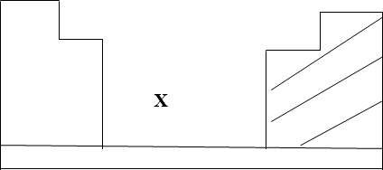

- With the help of vertical and horizontal lines, indicate the direction of increasing non-metallic nature of the elements. (2mks)
- Which type of elements are represented :
By X ? (1mk)
In the shaded area? (1mk)

(b)(i). Element A is in the same group of the periodic table as chlorine. Write the formula of the compound formed when A reacts with magnesium. (1mk)
…………………………………………………………………………………………………………
…………………………………………………………………………………………………………

- Soot is one of the environmental pollutants.
- Explain the term pollutant. (1mk)
…………………………………………………………………………………………………………
…………………………………………………………………………………………………………
- State how soot is formed from hydrocarbons. (1mk)
…………………………………………………………………………………………………………
…………………………………………………………………………………………………………

- What role do the following play in the commercial preparation of oxygen gas?
Concentrated sodium hydroxide. (1mk)
…………………………………………………………………………………………………………
Concentrated Sulphuric (VI) acid. (1mk)
…………………………………………………………………………………………………………

- Study the diagram below and answer the questions that follow.

flame
Dilute HCl
B
Zinc granules

A

(i).Write a chemical equation for the reaction that occurred at points:
  - A (1mk)

  - B (1mk)

(ii). A student set up the experiment bellow to collect gas K. the glass wool was heated before heating the magnesium coil.
Gas K
Cotton wool soaked in water magnesium coil

heat heat
(a). Explain why it was necessary to heat the moist cotton wool before heating the magnesium.2mk
…………………………………………………………………………………………………………
…………………………………………………………………………………………………………
…………………………………………………………………………………………………………
(b).Identify gas K. (1mk)
…………………………………………………………………………………………………………

(c).what property of gas K makes it possible to be collected by the method shown? (1mk)
…………………………………………………………………………………………………………

- Write a chemical equation for the reaction that produced gas K. (1mk)
…………………………………………………………………………………………………………

(e).The diagram represents two methods of gas collection in the laboratory.

Gas
Gas
  - (b)

- Name the methods of gas collection above. (2mks)
(a)………………………………………………………………………………………………………
(b)………………………………………………………………………………………………………

- Which method is suitable for collecting dry carbon (IV) oxide gas? Give a reason . (2mks)
…………………………………………………………………………………………………………
…………………………………………………………………………………………………………

The curves bellow represent the variation of temperature with time when pure and impure samples of a solid were heated separately.

Temperature
A
B

Time

(a). Which curve represents the variation in temperature for pure solid? Explain. (2mks)
…………………………………………………………………………………………………………

  - State the effect of an impurity on the melting and boiling points of a pure substance. (2mks)
…………………………………………………………………………………………………………
…………………………………………………………………………………………………………

(c). Name two gases used with oxygen in welding. (2mks)
…………………………………………………………………………………………………………
…………………………………………………………………………………………………………

6. The set up bellow was used to study some properties of air.
Moist iron Teat tube water

.Draw another diagram to show the level of water in the test tube after 24 hours. Explain the observations. (3mks)

- State and explain one observation made on the moist iron after 24 hours. (2mks)
…………………………………………………………………………………………………………
…………………………………………………………………………………………………………
…………………………………………………………………………………………………………

- State one disadvantage of rusting. (1mk)
…………………………………………………………………………………………………………
…………………………………………………………………………………………………………

- Fractional distillation of liquid air is usually used to separate various gaseous mixtures in air. Explain how nitrogen is obtained. (1mk)
…………………………………………………………………………………………………………
…………………………………………………………………………………………………………

- The PH of a soil sample in a given area was found to be 5.5. an Agricultural officer the addition of lime (calcium oxide). State the function of lime in the soil. (1mk)
…………………………………………………………………………………………………………
…………………………………………………………………………………………………………

FORM 2 MIDTERM 2 EXAMS

SERIES 1
CHRISTIAN RELIGIOUS EDUCATION
TIME: 2 HOURS

NAME……………………………………………………. ADM NO; …………………..

CLASS……………………………………………………… DATE……………………..

INSTRUCTIONS TO STUDENTS
  - Answer all questions in this question paper.
  - All your answers must be written in the spaces provided in this question paper.

QUESTIONS
- a) Give seven differences between the first and the second account of creation stories. (7mks) (b)State six consequences of sin according to (Gen 3, 4, 6 – 9, 11) (6mks) (c)Outline seven ways in which wrongdoers were punished in Africa society. (7mks)

- a)Outline seven reasons for the call of Abraham. (7mks)
- Describe how Abraham demonstrated his faith in God. (8mks)
- Identify ways in which Christians demonstrate their faith in God. (5mks)

- a) Outline the Old Testament prophecies about the Messiah. (8mks)
  - Outline what angel Gabriel revealed to Mary about Jesus Christ during the annunciation of his birth. (6mks)
  - State Four ways in which church leaders are preparing the people for the second coming of Christ. (6mks)

- (a)Explain the circumstances that led to the spread of idolatry in Israel. (8mks) (b)Give seven reasons why Elijah faced hostility and danger as a prophet of God. (7mks) (c)Outline the practices of idolatry in the society today. (5mks)

- a) Explain ways in which Jesus fulfilled the Old Testament prophesies about the Messiah
(7 mks)
- From the infancy stories(Luke 1&2) explain four occasions when people are given
divine revelation that Jesus is the promised messiah (8 marks)
- State five ways in which Christians spread the gospel of Christ (5 marks

- (a) State seven factors which promote harmony and mutual responsibility in Traditional African Communities. (7mks)
    - Explain the role of healers in Traditional African Communities (7mks)
    - Identify six factors undermining kinship ties in modern society (6mks)

FORM 2 MIDTERM 2 EXAMS

SERIES 1
ENGLISH
TIME: 2 HOURS

NAME……………………………………………………. ADM NO; …………………..

CLASS……………………………………………………… DATE……………………..

FOR EXAMINER’S USE ONLY

Question | Maximum  Score | Score
- Functional writing  - cloze test  - oral skills  - comprehension  - Grammar | 20  10  30  20  20
 | 100

1. FUNCTIONAL WRITING

In not more than 250 words,
Write a letter of apology to the head teacher of your school giving reasons as to why you did not attend the school’s academic day. (20mks)
…………………………………………………………………………………………………………
…………………………………………………………………………………………………………
…………………………………………………………………………………………………………
…………………………………………………………………………………………………………
…………………………………………………………………………………………………………
…………………………………………………………………………………………………………

…………………………………………………………………………………………………………
…………………………………………………………………………………………………………
…………………………………………………………………………………………………………
…………………………………………………………………………………………………………
…………………………………………………………………………………………………………
…………………………………………………………………………………………………………
…………………………………………………………………………………………………………
…………………………………………………………………………………………………………
…………………………………………………………………………………………………………
…………………………………………………………………………………………………………
…………………………………………………………………………………………………………
…………………………………………………………………………………………………………
…………………………………………………………………………………………………………
…………………………………………………………………………………………………………
…………………………………………………………………………………………………………
…………………………………………………………………………………………………………
…………………………………………………………………………………………………………
…………………………………………………………………………………………………………
…………………………………………………………………………………………………………
…………………………………………………………………………………………………………
…………………………………………………………………………………………………………
…………………………………………………………………………………………………………
…………………………………………………………………………………………………………
…………………………………………………………………………………………………………
…………………………………………………………………………………………………………
…………………………………………………………………………………………………………
…………………………………………………………………………………………………………
…………………………………………………………………………………………………………
…………………………………………………………………………………………………………
…………………………………………………………………………………………………………
…………………………………………………………………………………………………………

…………………………………………………………………………………………………………
…………………………………………………………………………………………………………
…………………………………………………………………………………………………………
…………………………………………………………………………………………………………
…………………………………………………………………………………………………………
…………………………………………………………………………………………………………
…………………………………………………………………………………………………………
…………………………………………………………………………………………………………
…………………………………………………………………………………………………………
…………………………………………………………………………………………………………
…………………………………………………………………………………………………………
…………………………………………………………………………………………………………
…………………………………………………………………………………………………………
…………………………………………………………………………………………………………
…………………………………………………………………………………………………………
…………………………………………………………………………………………………………

CLOZE TEST (10MKS)

Fill in the blank spaces with the most appropriate word.
‘I am done! I am done!’ my voice echoed in the forest. I wept aimlessly. I did know whether I was weeping because my friend was dying because I had very little hope of the next sunrise fell like a heavy
covering the whole country around us. A hyena, which was apparently watching helplessness, made anoise which sounded like a hoarse
laughter. frightened me so much that I could hear my own
beating. I shouted as as my empty stomach would allow me and the ran to the forest. From that day to this, when iam telling this story, I have never been confronted by such a problem.

ORAL SKILLS (30MKS)

Read the poem below and answer the questions that follow.
I had a dream last night. I dreamed I had to pick a mother out.
I had to pick a father too
At first, I wondered what to do, There were so many there, is seemed, Short and tall and thin and stout,
But just before I sprang awake,
I knew what parents I would take.

And this surprise and made me glad; They were the ones I always had!

Questions.
- Explain how the poet achieves rhythm in the poem (3mks)
…………………………………………………………………………………………………………
…………………………………………………………………………………………………………
…………………………………………………………………………………………………………
…………………………………………………………………………………………………………

- Which words would you stress in line 7 of this poem? (2mks)
…………………………………………………………………………………………………………
…………………………………………………………………………………………………………
…………………………………………………………………………………………………………

- How would you say the last line of this poem? (1mk)
…………………………………………………………………………………………………………
…………………………………………………………………………………………………………

- You are perfoming this poem to your classmates. How would you know that they are not concentrating? (4mks)
…………………………………………………………………………………………………………
…………………………………………………………………………………………………………

…………………………………………………………………………………………………………
…………………………………………………………………………………………………………
…………………………………………………………………………………………………………

- Identify the shortcomings in Nyasuguta’s telephone skills in the following conversation.
Nyasuguta: (Dialing a number) Is that Turbo wholesalers? Voice 1: Sorry, wrong number
Nyasuguta: (Tries several other numbers unsuccessfully and eventually gets it right) Is that Turbo wholesalers?
Voice2: Yes it is. Can I help you? Nyasuguta: I want to order Maize flour. Voice 2: How many bales, Madam?
Nyasuguta: Just a minute (turns from the phone and asks her husband how many bags they need). Ten bales.
Voice 2: Any preference in the brand?
Nyasuguta: of course! Everybody goes for pembe brand. Voice 2: Anything else, Madam?
Nyasuguta: No. But I want them delivered Voice 2: When and what address?
Nyasuguta: Before too long to shop number eight, Musembe shopping centre. Voice 2: Pardon, what was the number again?
Nyasuguta: (Impatiently and shouting) 8-9-5
Voice 2: We will deliver them in an hours time. Thank you Madam. It has been a pleasure doing business with you.

- Shortcomings (5mks)
…………………………………………………………………………………………………………
…………………………………………………………………………………………………………
…………………………………………………………………………………………………………
…………………………………………………………………………………………………………
…………………………………………………………………………………………………………
…………………………………………………………………………………………………………

- Identify instances of etiquette as used by voice 1 and 2 (4mks)
…………………………………………………………………………………………………………
…………………………………………………………………………………………………………
…………………………………………………………………………………………………………
…………………………………………………………………………………………………………
…………………………………………………………………………………………………………

- Identify the silent letter / sound in each of the following words. (6mks)
- Fracas –

- Bomb –

- feign-

- Psychology-

- wrap -

- Juice-

- In the following sets of words identify/ underline the odd one out.
- Choir chord chore chain

- Gas germinate grace guise

- cynic cycle census chat

- Chef chain chores charge

- Ambush Amass Amoeba Amaze

2. COMPREHENSION (20 MKS)
Read the passage below and answer the questions that follow

TATII’S PROBLEMS
She has lived a state of uncertainty since 1982. Her life has been dreary and full of disappointments. Her parents have been strict and demanding. She has had not time to visit her friends and cousins living upcountry. Every time, she has asked her parents to let her go and pay a visit to her friends, they have said, “You cannot go to visit your friends until you have finished your studies. Life had become very difficult in this country because of too many jobless young people. The situation has been made worse by the great number of examinations failures. No daughter of ours is going to be like these unemployed people. So you see, Tatii, you cannot go upcountry until your ‘O’ levels are over.

It has been like that for the past four years. Her life has been that of a zombie. She has listened to her mother’s sighs and her father’s preaching. The ‘O’ level results are out and her parents won’t believe that she has not passed.
What is she going to tell them? She had hoped to please her parents by securing entrance to the university, but all is now lost. Yes nearly lost. All would have been lost if Mrs. Ngueso, the school career teacher, hadn’t been called in to calm down Tatii and advise her parents.

Poor Mrs. Ngueso! She has had quite a task to save Tatii from her harsh parents. Tatii’s father has been the most difficult one to convince that Tatii is not the only girl who has failed her ‘O’ level examinations. As soon as he had seen Mrs Ngueso, he had started complaining that teachers no longer caned the children to make them work hard enough to pass their examinations. at some point in his discussion with Mrs. Ngueso, Tatii’s father had nearly lost his temper. But Mrs. Ngueso had been his match! She had braved his sour looks and insisted that it was Tatii they had met to discuss and not just any other school child.

She said, Tatii has worked well, but I has constantly appeared as if she has lacked the social support she needed to succeed. Tatii is a very girl but she has been very unhappy. Particularly lately. Sir, the girl needed moral support from you, her parents, as well as from school. The school can give some moral support and the academic support a child needs. But most of all the parents have always been expected to encourage their children in the most crucial movements of their life. May be you and to some extent the school, owe Tatii some assistance.

Now Tatii’s mother spoke for the first time. “Baba Tatii, let us do as Mrs. Ngueso says. The child has been very unhappy. I haven’t told you this bhut since the appearance of the examination results I have lived in fear. Tatii has behaved very strangely at times. Her friends have reported that she was planning to run away from home. Please let us give her a second chance”

Tatii’s father turned and looked at his wife for the first time sine Mrs. Ngueso arrival. He saw in her pleading eyes the pain of a loving mother. He quickly looked away. At that moment he realized how very blind he had been to his wife and daughters suffering. He rose to leave, turned and extended his hand to Mrs. Ngueso and said, ;Thank you very much, mwalimu Tatii will be in school at the beginning of term. Then he left the room.

- Why does the author describe Tatii life as having been dreary? (1mk)
…………………………………………………………………………………………………………
…………………………………………………………………………………………………………

- What excuse have Tatii parents constantly given for not allowing her to visit her relatives and friends. (2mk)
…………………………………………………………………………………………………………
…………………………………………………………………………………………………………

- Why was Tatii so unhappy after the results of the examinations came out. (1mk)
…………………………………………………………………………………………………………
…………………………………………………………………………………………………………

- What was Tatii father reactions to her results? (1mk)
…………………………………………………………………………………………………………
…………………………………………………………………………………………………………

- State the reasons Mrs. Ngueso gives for Tatii problems (2mks)
…………………………………………………………………………………………………………
…………………………………………………………………………………………………………

- What evidence is there in the passage to show that Tatii mother was more understanding than the father? (3mks)
…………………………………………………………………………………………………………
…………………………………………………………………………………………………………
…………………………………………………………………………………………………………
…………………………………………………………………………………………………………

- Compare Mrs Ngeuso’s character and that of Tatii’s father. Put your answer in the table below.
( 4mks)

Character | Character Trait | Illustrations from the text
Mrs. Ngueso
Tatii’s Father

- Explain the meaning of the following words and phrases as used in the passage Dreary

Demanding

Zombie

Security entrance Harsh
Braved (6mks)

GRAMMAR. (20MKS)
- Give the plural forms of the words listed below.
- Ox –
- stadium –
- Radius-
- Oasis –
- Goose- (3mks)

- Rearrange the following words the order in which they would appear in the dictionary.
- trachea, tweet, tragedy, thump, thirst.

- Mongrel, Frenzy, target, puzzle.

- climate, cataract, cokpit, captive, cock

- Head lamp, headgirl, headboy, head teacher (2mks)

- Complete the following collective nouns using the appropriate word.
- A of journalists.

- A of flowers.

- A of judges

- A of monkeys

- A of sheep. (2 ½ mks)

- The words below are misspelled, correct them.
- profesar
- Tomorow
- Imediately
- Pronounciation (2mks)

- Use suitable pronouns to replace the underlined nouns.
- The wheather is changing. The wheather is becoming rather chilly.

- Mary took the book. She said it was Mary’s.

- People don’t like liars. People say liars are no better than murderers.

- Otieno is a very good leader. (2mks)

- Join the following sentences using the conjunctions listed below. Avoid unnecessary repetition, and, but so also, or.
- Tigers are beautiful animals. Tigers are dangerous animals.

- You can borrow my pen. You can buy one from the shop.

- They went to the theatre. They bought tickets for “passion of Christ”

- The train was booked up. I went by Akamba bus. (2mks)

- Rewrite the following sentences using either the comparative or superlative form of adjectives in brackets.
- Statistics show that (much) enegy is consumed by industry than by individuals.

- Susan is the (tall) girl in our class.

- This book is (expensive) than that one.

- The Atacama Desert in Chile is the (dry) in the world. (2mks)

Fill in the blanks in the following passage with appropriate prepositions.
Breakfast was usually served 6.30 am. Every recruit the camp was expected to be the parade ground 7.15 am.
this particular Wednesday I had woken up feeling very low and my head was clouded a myriad thoughts the impending events the camp. (4 ½ mks)

FORM 2 MIDTERM 2 EXAMS

SERIES 1
KISWAHILI
TIME: 2½ HOURS

NAME……………………………………………………. ADM NO; …………………..

CLASS……………………………………………………… DATE……………………..

MAAGIZO
- Andika jina na nambari yako katika nafasi ulizoachiwa hapo juu
- Jibu maswa yote. Majibu yaandikwe katika nafasi zilizoachwa kwenye kijitabu hiki cha maswali
KWA MATUMIZI YA MTAHINI PEKEE

Swali | Upeo | Alama
1 | 15
2 | 15
3 | 40
4 | 10
Jumla | 80

UFAHAMU (ALAMA 15)
Soma taarifa ifuatayo halafu ujibu maswali
Kama kuna jambo ambalo limeiparaganya akili yamahuluki ni kuielewa dhana ya demokrasia. Kiumbe huyu heshi kuuliza mkururo wa maswali. Demokrasia ni nini hasa? Tunaweza kula demokrasia? Ni dude gani hili lina kichwa au mkia pekee yake? Je demokrasia inazuia njaa? Demokrasia ni himaya ya wasomi tu au vilevile ni haki ya mafalahi? Kwa muda mrefu kumekuwa na kinyang’anyiro kikubwa katika jamii ambacho azma na. matokeo yake yamekuwa ya kutatanisha. Baadhi ya watu wamejitokeza kama mchuzi wa ugali na kuzusha zahama ambazo si za kuyumkinika. Vichwa vya adinasi vikafyekwa kwa miundo na maparange na matumbo yakapasuliwa na kuapakaza utumbo na vijusi kila mahali. Shingo zikapigiwa vigingi na

kukomewa ardhini. Demokrasia si mchezo wa lelemama. Ni sharti tujifunge vibwebwe tumwage damu na tufe ili tupate demokrasia ya kweli!” Mmoja wa mibabe wa demokrasia alinguruma kadamnasi ya umati huku ngoma za vita zikirindima.” Hata Marekani na ulaya walimwaga damu. Mamilioni ya watu walipukutishwa na kimbunga cha demokrasia. Chini walilaliana kama Vimatu na tunutu. Hawa manafiki wanafikiri hatuwajui. Katu hatutakubali porojo zao. Wanatupikia majungu kisha wakatoweka. Kuna demokrasia ya Afrika na ile ya Ulaya ‘ mkereketwa wa Uafrika akachanganua.
Demokrasia ya Afrika basi imefuata mkondo huu wa umwagikaji damu. Kila kukijiri uchaguzi zahama hutawala. Walio madarakani hawataki kubanduka. Hutaruta visababu vya kukwepa wimbi la ushinde. Demokrasia ni mchezo wa mizengwe tu ati. Hali hil imesababisha maafa makubwa, uharibifu mkubwa wa mali, majeraha, ukimbizi wa raia ndani na nje ya mataifa husika, dhuluma za kimapenzi dhidi ya wanawake, kuzagaa kwa magonjwa ainati, uhasama wa kikabila. Jambo la kusikitisha ni kwamba raia na viongozi hawaelekei kujifundisha chochote kutokana na hali. Huku mataifa mengi Ulayani na Asia yakikwea daraja moja baada ya nyingine kimaendeleo, Afrika imedumaa tu. Imesalia kuimba ule wimbo wake wa kutokea azali‘ Tutaendelea vipi na tunadhulimiwa na kaka wakubwa”. Siasa ya demokrasia katika bara la Afrika ina tija kubwa hususan kwa wale wachache wanaofanikiwa kudhibiti nyenzo za kutia tonge kinywani. Ulitima wa umma husalia miradi hewa ya tabaka la viongozi ambayo hutumiwa kujinadi zamu nyingine ifikapo tena. Demokrasia ya kweli imo mikononi mwa umma pale utakapojikomboa kimawazo na kwa ujasiri kudai huduma bora, uajibikaji na kuheshimiwa kwa mkataba wa kijamii uliosisiwa na Jean Jacques Rousseau.

MASWALI
  - Binadamu amechanganyika kwa njia ipi) (Alama 2)
…………………………………………………………………………………………………………
…………………………………………………………………………………………………………
…………………………………………………………………………………………………………

  - Ni vipi Demokrasia ya kweli inaweza kufikiwa (Alama 2)
…………………………………………………………………………………………………………
…………………………………………………………………………………………………………
…………………………………………………………………………………………………………

  - Kwa nini inasemekana kuwa ‘Demokrasia ni mchezo wa mizengwe? (Alama 2)
…………………………………………………………………………………………………………
…………………………………………………………………………………………………………
…………………………………………………………………………………………………………

  - Ni athari gani hutokana na kinyang’anyiro cha Demokrasia? (Alama 4)
…………………………………………………………………………………………………………
…………………………………………………………………………………………………………
…………………………………………………………………………………………………………
…………………………………………………………………………………………………………
…………………………………………………………………………………………………………

  - “Dhiki za raia zimesalia kuwa mradi-hewa wa wanasiasa” Eleza. (Alama2)
…………………………………………………………………………………………………………
…………………………………………………………………………………………………………
…………………………………………………………………………………………………………
…………………………………………………………………………………………………………
…………………………………………………………………………………………………………

  - Fafanua maana ya maneno na mafungu yafuatayo jinsi yalivyotumika katika taarifa.
(Alama 3)
Mafahali
…………………………………………………………………………………………………………
…………………………………………………………………………………………………………
Wanatupikia majungu
…………………………………………………………………………………………………………
…………………………………………………………………………………………………………
Ukarabati
…………………………………………………………………………………………………………
…………………………………………………………………………………………………………

UFUPISHO (ALAMA 15)
Soma makala yafuatayo kasha ujibu maswali yanayofuata
Wakaazi wengi wa maeneo ya kitajiri miji yetu hawajui wapo chini ya utawala wa machifu.Huenda wakasalia katika hali hii ya kutojua hadi wanapokosa kulipa ujira wa watumishi wao wa nyumbani halafu maskini mwajiriwa huyu anaripoti kwa chifu, kwa kuwa ni hali yake.

Chifu ni uzi muhimu katika vazi Ia kijamii. Bila hawa maafisa, jamii kama tunavyoijua ingeporomoka. Wakati mwingine hawaungwi mkono. Mfano mzuri ni kukataliwa kwa katiba kielelezo cha Wako, Novembe 2005, wakati wa kura ya maoni. Kwa sababu jukumu la chifu au kibadala chake halikudhihirishwa wazi wazi katika kielelezo, wengi walikataa stakabadhi hiyo, wakihofia sasa hawataweza kufikia mtawala wao kushughulikia malalamishi yao.
Nimeishi mtaa wa Nairobi West miaka mingi na kuhudhuria kamati nyingi za lokesheni, chini ya uwenye kiti wa chifu akisaidiwa na naibu na wazee. Mikutano, pia inahudhuriwa na madiwani, inspekta wa askari tawala na wawakilishi wengi na washia dau katika lokesheni. Takribani kila swali linalogusia maslahi ya jamii linajadiliwa na kuchunguzwa na maazimio kupitishwa. Mada muhimu wakati wa mikutano hii ni usalama, taa za barabarani, ulanguzi wa mihadarati hasa karibu na taasisi za elimu, kudumisha usafi wa vyoo vya umma, kudumisha usalama kupitia kwa raia na swala nyeti la vioski.
Kazi ngumu ya chifu ni kuwazia kila kju. Kwa mfano, mwenye kioski ni sharti apate mkate wa kila siku na sehemu ya biashara yake iliyoko ni muhimu. Ikiwa kioski kitajengwa na kukiuka sheria za
baraza la jiji au ikiwa wizi usiofahamika na utumizi wa dawa za kulevya unatokea kufuatia kukua kwa idadi ya vioski katika eneo, shinikizo zinaelekezwa kukuwa kwa wenye vioski. Chifu lazima azingatie shinikizo za umma hatari za kiusalama na hofu za wenye vioski kabla ya kufanya uamuzi ikiwa mijengo hiyo ibomolewe.
Tatizo jingine ni watoto wa barabarani. Makao ya kuwakimu ni machache kama walivyo wahudumu wa kijamii, suluhu ni nini? Tuwatupe katika ukumbi wa kijamii, ambao watahepa pindi tu, wapatapo fürsa ndogo au wapelekwe huduma kwa vijana wa Taifa, ambapo wachache wanaweza kutunzwa kwa wakati mmoja. Ili kufaulu kwa wengine, sharti wawe katika vituo vya urekebishaji tabia za matumizi ya dawa za kulevya. Tuwakabidhi polisi kwa sababu wanaranda au tujaribu kuungana na vituo vya urekebishaji tabia kuhakikisha hawatarudi barabarani.
Mazingira ya lokesheni pia huibuka katika ajenda. Hali ya barabara, juhudi za kusafisha mazingira, wizi wa maji na umeme, usafiri wa umma, uchafuzi wa mazingira, hewa na kelele, hii inatokea kupitia malalamishi ya watu wanaoishi karibu na mabaa na uzingativu wa saa ya biashara hujadiliwa kila mara. Chifu ni sharti afahamu sheria na kanuni zinazotawala hali hizo, halafu ajadili na wahusika kabla ya kutoa mwelekeo. Usawa na uwazi katika kugawa fedha za Hazina ya maendeleo ya maeneo Bunge, pia hujadiliwa.
Katika maswala haya mengine, chifu ndiye aliye nyanjani. Anawajibikia jamii na wakubwa wake na hatarajii shukrani au kutambuliwa kwa kazi njema aliyofanya. Isipokuwa hukashifiwa anapofeli. Watu wengine wana taswira ya Chifu kama mtu kwenye jukwa, kofia yake. na kifimbo kinachompa mamlaka ya kuhutubia baraza, Kajubu tyji zaidi ya hivyo. Kwa mujibu wa kitabu cha
mafunzo ya machifu na Naibu wao (Januari 2004), wajibu wa chifu ni kuwakilisha sera na mipango ya serikali kwa wananchi. Chifu ni ajenti wa “mabadiliko” mwenye wajibu Wa kuhamasisha watu katika maendeleo. Anajishughulisha na kujua ni nani maskini katika lokesheni, mkoa, mgonjwa asiyeweza kupata tiba na kupanga jinsi mhasiriwa atakavyopelekwa hospitali kama anavyoweza. Ni sharti ashughulikie ugomvi wa kinyumbani, uhalifu wa watoto, dhuluma za watoto, agawe

chakula na mavazi kwa wahitaji na kuhukumu kesi ndogo za wizi na uharibifu. Chifu hutatua kesi za kisheria kwa wasioweza kumudu wakili. Wakati wananchi wanapohisi mbunge wao hafikiliki na hawana imani na polisi, chifu ndiye suluhisho.
Lakini kuna machifu wachache ambao hawafanyi kazi yao vyema. Kwa ufupi, chifu ni mkusanyiko wa kushngaza; mfalme katika himaya yake, pasta, baba msikivu, wanasaikolojia, mtunga sheria na mdumisha sheria, balozi mchaguzi, mama, mlumbi na askari asiyechelewa. Ingawa halipwi vyema, anafanya kazi bila tarakilishi, na aghalabu hujilipia gharama ya kodi ya afisi yake kutoka mfuko wake. Kwa sababu ni mtumishi wa umma, tunataraji afanye kazi mufti. Hiyo haimaanishi tusishukuru kwa kazi njema aliyofanya. Serikali inaweza kufanya hivi kwa kuimarisha hali yake ya kazi, mazingira yake ya kikazi, na kuhakikisha yana tarakilishi, anapata mafunzo ya uongozi na usimamizi. Wananchi sharti washukuru watu hawa kwa kujitolea sabili.

Maswali
- Fupisha aya nne za kwanza (Maneno 60) (Alama 6, mtiriko,1)
Matayarisho
…………………………………………………………………………………………………………
…………………………………………………………………………………………………………
…………………………………………………………………………………………………………
…………………………………………………………………………………………………………
…………………………………………………………………………………………………………
…………………………………………………………………………………………………………
…………………………………………………………………………………………………………
…………………………………………………………………………………………………………
…………………………………………………………………………………………………………
Jibu
…………………………………………………………………………………………………………
…………………………………………………………………………………………………………
…………………………………………………………………………………………………………
…………………………………………………………………………………………………………
…………………………………………………………………………………………………………
…………………………………………………………………………………………………………
…………………………………………………………………………………………………………
…………………………………………………………………………………………………………
…………………………………………………………………………………………………………

- Kwa maneno kati ya 80-90 fupisha aya ya tano hadi mwisho. (Alama 9, mtiririko 1)
Matayarisho
…………………………………………………………………………………………………………
…………………………………………………………………………………………………………
…………………………………………………………………………………………………………
…………………………………………………………………………………………………………
…………………………………………………………………………………………………………
…………………………………………………………………………………………………………
…………………………………………………………………………………………………………
…………………………………………………………………………………………………………
…………………………………………………………………………………………………………
…………………………………………………………………………………………………………
…………………………………………………………………………………………………………
…………………………………………………………………………………………………………
…………………………………………………………………………………………………………

Jibu
…………………………………………………………………………………………………………
…………………………………………………………………………………………………………
…………………………………………………………………………………………………………
…………………………………………………………………………………………………………
…………………………………………………………………………………………………………
…………………………………………………………………………………………………………
…………………………………………………………………………………………………………
…………………………………………………………………………………………………………
…………………………………………………………………………………………………………

- MATUMIZI YA LUGHA (ALAMA 40)
  - i)Taja sauti mbili ambazo ni vikwamizo na hutamkiwa kwenye ufizi (Alama 1)
…………………………………………………………………………………………………………
…………………………………………………………………………………………………………

ii) Taja sifa mbili bainifu za vokali ‘U’ (Alama 2)
…………………………………………………………………………………………………………
…………………………………………………………………………………………………………
…………………………………………………………………………………………………………

  - Yakinisha sentensi hii. (Alama 2)
Simba asiponguruma wanyama wote hawababaiki.
…………………………………………………………………………………………………………
…………………………………………………………………………………………………………
…………………………………………………………………………………………………………

  - Andika upya sentensi ifuatayo kwa kufuata maagizo uliyopewa. (Alama 2)
Mbwa ambaye aliripotiwa kuwa ameibwa amepatikana katika bwawa la maji. (Anza: Katika bwawa )
…………………………………………………………………………………………………………
…………………………………………………………………………………………………………
…………………………………………………………………………………………………………

  - Changanua sentensi ifuatayo kwa kutumia mbinu ya matawi (Alama 4)
Mwanafunzi stadi amenunua kitabu kizuri.
…………………………………………………………………………………………………………
…………………………………………………………………………………………………………
…………………………………………………………………………………………………………
…………………………………………………………………………………………………………
…………………………………………………………………………………………………………
…………………………………………………………………………………………………………

  - Ukizingatia neno lililo katika mabano, andika sentensi hizi katika hali ya kutendeka.
    - Daraja hili(vuka) tu wakati wa kiangazi (Alama 1)
…………………………………………………………………………………………………………
…………………………………………………………………………………………………………
    - Kitabu hicho(soma) ijapokuwa sura zingine hazimo. (Alama 1)
…………………………………………………………………………………………………………
…………………………………………………………………………………………………………
  - Andika katika ukubwa wingi (Alama 2)
Kitoto kijeuri kikiletwa kitarejeshwa kwao.
…………………………………………………………………………………………………………

  - Andika katika usemi taarifa. (Alama 2)
“Tutawatembelea wazazi wetu leo jioni” Leo alimwambia Asha.
…………………………………………………………………………………………………………
…………………………………………………………………………………………………………

  - Tunga sentensi ukitumia nomino zifuatazo pamoja na kivumishi ingine(Alama 2)
  - dau
…………………………………………………………………………………………………………
…………………………………………………………………………………………………………
ii) urembo
…………………………………………………………………………………………………………
…………………………………………………………………………………………………………

- Bainisha yambwa tendwa na yambwa tendewa katika sentensi hii. (Alama 2)
Mbunge wa Mtondo Kaskazini atawajengea wanakijiji josho kisha aghurie mjini.

- Tunga sentensi ukitumia viwakilishi vifuatavyo. (Alama 2)
  - Nafasi viambata
…………………………………………………………………………………………………………
…………………………………………………………………………………………………………

  - Visisitizi
…………………………………………………………………………………………………………
…………………………………………………………………………………………………………

- Tumia neno dhahiri katika setensi kulingana na maagizo (Alama 3)
Kama:
- Kiambishi
………………………………………………………………………………………………………
……………………………………………………………………………………………………

- Kivumishi
………………………………………………………………………………………………………
……………………………………………………………………………………………………

- Tunga sentensi ya neno moja yenye visehemu vifuatavyo vya sarufi. (Alama 3)
  - Kiambishi kiwakilishi cha kiima
  - Kiambishi kiwakilishi cha wakati uliopo
  - Kiambishi kiwakilishi cha kitendewa/mtendewa
  - Shina la kitenzi
  - Kiambishi cha kauli ya kutendesha
  - Kiishio
…………………………………………………………………………………………………………
…………………………………………………………………………………………………………
…………………………………………………………………………………………………………
…………………………………………………………………………………………………………

- Bainisha kirai nomino na kirai kivumishi katika sentensi hizi. (Alama 2)
  - Nguo aliyonunua mzazi ni mpya.
…………………………………………………………………………………………………………
…………………………………………………………………………………………………………

  - Kondoo mwenye manyoya mengi hupendeza.
…………………………………………………………………………………………………………
…………………………………………………………………………………………………………

- Akifisha (Alama 3)
sikukuu ya madaaraka nilikwenda eldama ravine kumwona yohana akasema atakuja kuniona pamoja na mkewe siku ya jumapili
…………………………………………………………………………………………………………
…………………………………………………………………………………………………………
…………………………………………………………………………………………………………
…………………………………………………………………………………………………………
…………………………………………………………………………………………………………

- Eleza tofauti za kimaana baina ya sentenzi hizi. (Alama 4)
  - Jambazi kutoka dukani aliiba
  - Kutoka dukani jambazi aliiba.
  - Aliiba jambazi kutoka dukani.
i) Jambazi aliiba kutoka dukani.
…………………………………………………………………………………………………………
…………………………………………………………………………………………………………
…………………………………………………………………………………………………………
…………………………………………………………………………………………………………
…………………………………………………………………………………………………………
…………………………………………………………………………………………………………

- Unda nomino mbilimbili kutokana na mizizi ifuatayo. (Alama 2)
  - -f-
…………………………………………………………………………………………………………
…………………………………………………………………………………………………………
  - -l-
…………………………………………………………………………………………………………
…………………………………………………………………………………………………………

ISIMU JAMII (ALAMA 10)
  - Eleza maana ya lugha (Alama 1)
…………………………………………………………………………………………………………
…………………………………………………………………………………………………………

  - Taja sifa nne za lugha (Alama 4)
…………………………………………………………………………………………………………
…………………………………………………………………………………………………………
…………………………………………………………………………………………………………
…………………………………………………………………………………………………………
…………………………………………………………………………………………………………

  - Eleza sifa za sajili ya maabadani (Alama 5
…………………………………………………………………………………………………………
…………………………………………………………………………………………………………
…………………………………………………………………………………………………………
…………………………………………………………………………………………………………
…………………………………………………………………………………………………………
…………………………………………………………………………………………………………
…………………………………………………………………………………………………………
…………………………………………………………………………………………………………

FORM 2 MIDTERM 2 EXAMS

SERIES 1
PHYSICS
TIME: 2½ HOURS

NAME……………………………………………………. ADM NO; …………………..

CLASS……………………………………………………… DATE……………………..

SECTION A (25MARKS)

Answer all question this section
- Distinguish between mass and weight of a body stating the S.I units for each. (2mks)
…………………………………………………………………………………………………………
…………………………………………………………………………………………………………
…………………………………………………………………………………………………………

- 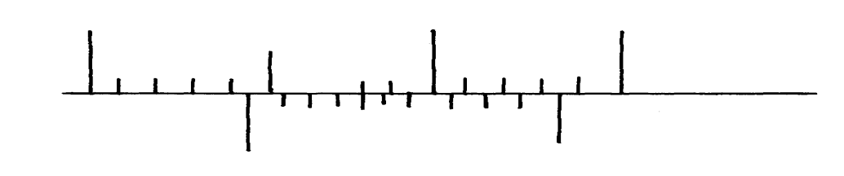The figure below shows part of scale of vernier calipers.
7cm
8cm
0
10

What is the reading indicated on the scale (1mk)

- 180cm3 of fresh water of density 100kg/m3 is mixed with 2200cm3 of sea water of density 1025kg/m3. Calculate the density of the mixture (4mks)

- Explain why fish can survive under water when the surface is already frozen (2mks)
…………………………………………………………………………………………………………
…………………………………………………………………………………………………………
…………………………………………………………………………………………………………

- 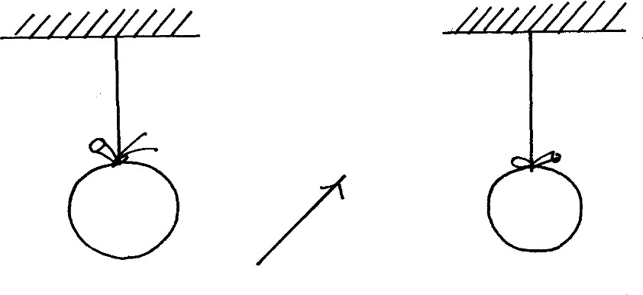Two inflated balloons are at the same level while suspended from threads a short distance apart as shown below;
Air blown

Some air is blown gently in the space between the balloon in horizontal direction. Explain
what happens to the balloons. (2mks)
…………………………………………………………………………………………………………
…………………………………………………………………………………………………………
…………………………………………………………………………………………………………

- State one advantage of an alkaline battery over a lead acid battery. (1mk)
…………………………………………………………………………………………………………
…………………………………………………………………………………………………………

- The diagram below shows a permanent magnet suspended by a spring. State with reason the behaviour of the magnet when the switch is closed. (2mks)

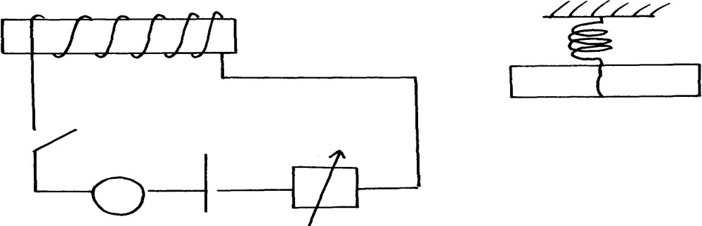
X
Y
N
Spring
S
S
+ -
A

…………………………………………………………………………………………………………
…………………………………………………………………………………………………………

- Convection and diffusion both involve motion of fluids. Distinguish between the two. (2mks)
…………………………………………………………………………………………………………
…………………………………………………………………………………………………………
…………………………………………………………………………………………………………

- A negatively, charged rod is brought close to (but not touching ) an uncharged sphere. If the sphere is momentarily earthed and then the rod is removed, briefly explain what happens. (2mks)
…………………………………………………………………………………………………………
…………………………………………………………………………………………………………
…………………………………………………………………………………………………………

- Indicate on the diagram below, the level of mercury in the tubes X and Y (2mks)

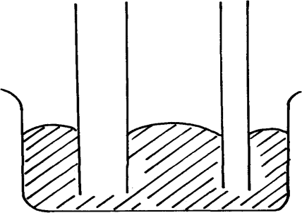Mercury
X
Y

- An object weighs 1200N on a certain planet. What is the gravitational field strength of this planet if the object is 60kg? (3mks)

- State two properties of a thermometric liquid. (2mks)
…………………………………………………………………………………………………………
…………………………………………………………………………………………………………

SECTION B (55MARKS)

Answer all question this section

- Define pressure and give its S.I nits. (2mks)
…………………………………………………………………………………………………………
…………………………………………………………………………………………………………
- The diagram below represents a motor car hydraulic braking system;

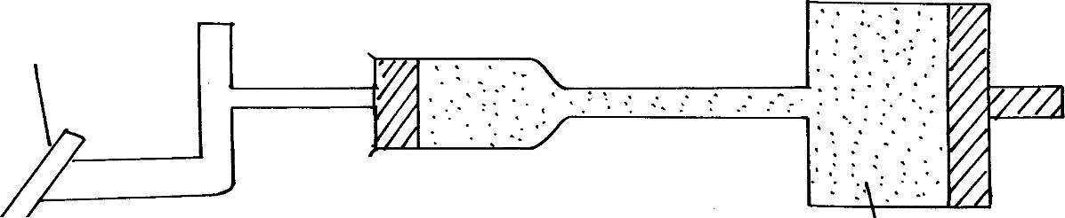B
Brake pedal
A
Master piston

Slave piston brake fluid

- State two properties of the liquid used as a brake fluid (2mks)
…………………………………………………………………………………………………………
…………………………………………………………………………………………………………

- Given that in the diagram (b) above the master piston has an area of 15cm2 and the slave piston has an area of 50cm2 a force of 100N is applied on the master piston. Find the force
used to stop the car. (3mks)

- Compare the values of pressure in the two pistons above and give a reason for your answer.
(2mks)
…………………………………………………………………………………………………………
…………………………………………………………………………………………………………
…………………………………………………………………………………………………………

- Give a reason why gas is not suitable for use in place of the brake fluid. (1mk)
…………………………………………………………………………………………………………
…………………………………………………………………………………………………………

- Xcm3 of substance A which has density of 800kg/m3 is mixed with 100cm3 of water with a density of 1000kg/m3. The density of the mixture is 960kg/m3. Determine the value of X (3mks)

- Give reasons why it is necessary to leave the caps of the cells open when charging an accumulator (1mk)
…………………………………………………………………………………………………………
…………………………………………………………………………………………………………

- Define current and state its SI unit (2mks)
…………………………………………………………………………………………………………
…………………………………………………………………………………………………………
…………………………………………………………………………………………………………

- A charge of 120 coulombs flow through a 1 am every minute. Calculate the current flowing through the lamp. (3mks)

- What do you understand by open and closed circuits. (2mks)

D
D
C
B

- State the polarities of A and B. (2 mks)
…………………………………………………………………………………………………………
…………………………………………………………………………………………………………
…………………………………………………………………………………………………………

- Name the chemical substances in the parts labeled C and D (2mks)
…………………………………………………………………………………………………………
…………………………………………………………………………………………………………
…………………………………………………………………………………………………………

- The figure shows an arrangement of source of light, an opaque object and a screen. Using A, B and C as point sources, sketch on the same diagram labeled a ray diagram to show what is observed on the screen. (3mks)

A B C

- In a certain pinhole camera, the screen is 10cm from the pinhole. When the pinhole is placed 6cm away from a tree, a sharp image of a tree 16cm high is formed on the screen. Find the height of the tree. (3mks)

- Distinguish between Lunar and Solar eclipse by stating the events that lead to the formation of each (4mks)
…………………………………………………………………………………………………………
…………………………………………………………………………………………………………
…………………………………………………………………………………………………………
…………………………………………………………………………………………………………
…………………………………………………………………………………………………………

- A girl stands 4 m in front of a plane mirror
- What is the distance between the girl and the mirror (3mks)
…………………………………………………………………………………………………………
…………………………………………………………………………………………………………
…………………………………………………………………………………………………………
…………………………………………………………………………………………………………
…………………………………………………………………………………………………………

- Explain how you would use an electroscope to distinguish between a conductor and an insulator (3mks)
…………………………………………………………………………………………………………
…………………………………………………………………………………………………………
…………………………………………………………………………………………………………
…………………………………………………………………………………………………………

- Fill in the table of charges appropriately ( 5mks)

Charge on Electroscope | Charge brought near cap | Effects on leaf divergence
+  - | +  -
+ or - | Uncharged body

- What is the name given to the method of charging an electroscope where it requires an opposite charge to the one of the charging materials? (1mk)
…………………………………………………………………………………………………………
- Distinguish between a basic physical quantity and a derived physical quantity giving an example of each. (3mks)
Physical quantity | Derived physical quantity
- State any two ways by which frictional force between two surfaces can be reduced. (1mk)
…………………………………………………………………………………………………………
…………………………………………………………………………………………………………

- Explain why large mercury drops form oral ball on a glass slide (2mks)
…………………………………………………………………………………………………………
…………………………………………………………………………………………………………
…………………………………………………………………………………………………………

- Explain why a man using a parachute falls through air slowly while a stone falls through air very fast. (2mks)
…………………………………………………………………………………………………………
…………………………………………………………………………………………………………
…………………………………………………………………………………………………………

FORM 2 MIDTERM 2 EXAMS

SERIES 1
MATHEMATICS
TIME: 2½ HOURS

NAME……………………………………………………. ADM NO; …………………..

CLASS……………………………………………………… DATE……………………..
INSTRUCTIONS TO STUDENTS
  - Answer all questions in this question paper.
  - All your answers must be written in the spaces provided in this question paper.

- Evaluate without using tables or calculators. (3mks)

- The sum of interior angles of a regular polygon. Find the size of each exterior angle. (3mks)

- The length of an arc of a circle is of its circumference. If the area of the circle is 346.5cm², find the angle subtended by the arc at the Centre of the circle. (4mks)

- Given that x=2y and 3y=5z. find the ratio x:y:z hence or otherwise find the amount of money Ali got if Ali, Ben and Chris shared Kshs. 36000 in the ratio x:y:z respectively. (4mks)

- A plane leaves town A for town B at 0540 hours. If the journey takes 6.5 hours, at what time does the plane reach its destination? (3mks)

- A cylindrical solid metal is 3m long and has a mass of 4kg. if its density is 5.6g/cm3, find the radius of its end. (take π=3.142) (4mks)

- Express the number 9000 as a product of its prime factors. (1mk)

b) Find the value of P if the number 9000P is a perfect cube. (2mks)

- Find the value of T given that T= and a=2, b=-1,and c=-3 (3mks)

- A shop keeper sells a shirt for Kshs. 350 thereby making a profit of 40%. Calculate the buying price of the shirt. (3mks)

- The GCD of three numbers is 45 and their LCM is 18900. Two of the numbers are 675 and
540. Find the other possible numbers. (2mks)

- Find the perimeter of the figure below. (Take π=22/7). (3mks)

3.5cm

750

- John is twice as old as his friend Peter. Peter is 5 years older than Alice. In 5 years John will be three times as old as Alice. How old is Peter now? (3mks)

- Ondieki had travelled from Texas to Kenya and arrived with U$17500 on 12/2/2013. On arrival he changed the dollars into Kenya shillings and immediately used Kshs. 850,000. Later on 15/2/2013 he had some immediate use of £3600 and therefore c hanged all the money he had into sterling pounds. Finally on 18/2/2013 he converted what remained to Kenya shillings.
Buying Selling
Kshs.Kshs.
12/2/2013 U$ 82.36 85.74
15/2/2013 £ 110.14 118.26
18/2/2013 £ 112.64 119.56
How much did he remain with in Kenya shillings? (3mks)

- The sum of the digits of a two digits number is 13. If the digits are reversed the number decrease by 27. Find the number. (3mks)

- A man walks to work at 16km/hr and back home at 5km/hr. find the distance from his work place if the whole journey takes him 2 hours 12 minutes. (3mks)

- If 3=- , find the ratio (3mks)

SECTION II (50 MARKS)
ANSWER ANY FIVE QUESTIONS
- (a) Using a ruler and a pair of compasses only construct a triangle ABC such that AB=4cm, BC=5cm and ےABC=1200. Measure AC. (4mks)

- On the diagram, construct a circle which passes through the vertices of the triangle ABC. Measure the shortest distance from the centre of the circle to line BC. (4mks)

- Measure the radius of the circle. (2mks)

- Two aero planes P and Q leave an airport at the same time. P flies on a bearing of 2400 at 900km/h while Q flies due East at 750km/h.
a) Using a scale drawing of 1cm to represent 100km, make a scale drawing to show the positions of the planes after 40 minutes. (5mks)

b) | Determine the bearing of
i) | P from Q | (2mks)
ii) | Q from P | (2mks)
c) | Find the shortest distance between plane P and plane Q after 40 minutes. | (1mk)

- A construction company requires to transport 144 tonnes of stones to sites A and B. the company pays Kshs. 24000 to transport 48 tonnes of stone for every 28 km. kimani transported 96 tonnes to a site A, 49km away.
- Find how much he paid. (3mks)

- Kimani spends Kshs. 3000 to transport every 8 stones to the site. Calculate his total profit.
(4mks)

- Achieng transported the remaining stones to sites B, 84km away. If she made 44% profit, find her transport cost. (3mks)

- A tank has two inlet taps P and Q and an outlet tap R. when empty, the tank can be filled by tap P in 41/2 hours and by tap Q in 3 hours. When full the tap can be emptied in 2 hours by tap R.
- The tank is initially empty, find how long it would take to fill up the tank;
- If tap R is closed and taps P and Q are opened at the same time. (3mks)

- If all the three taps are opened at the same time. (3mks)

- Find the fraction of the tank that would be filled by 9.00am if initially the tank is empty and the taps are opened as follows. (4mks)
P at 8.00 am R at 9.00 am Q at 8.45 am

- a) Plot the graphs of the equations y=2x + 3 and y=-x +3. (4mks)

- Use your graph to find the coordinates of the point of intersection of the two lines. (2mks)

- Hence, state the solutions to the equations y=2x + 3 and y=-x +3. (2mks)

- Find the angle made by the line y=2x+3 and the x-axis. (2mks

- A coffee farm was surveyed and its measurements entered in a field book as shown below. (Take XY=400m as the baseline.)
Y
360 80 to Q to R 80 280
to S 160 200
40 200 to P
X
- Using a scale of 1cm to represent 40m, draw the map of the coffee farm. (3mks)

- Find the area of the coffee farm in hectares. (7mks)

- A model of a tent consists of cube and a pyramid on a square base as shown below.

8cm
5cm
8cm

- Draw accurately the net of the model. (2mks)

- Use the net to calculate the total surface area of the model. (4mks)

- If the ratio of the area of the model to the area of the actual is 1:10000, find the area of the material required to make the tent (floor area inclusive) in m2. (4mks)

- a) Water and alcohol are mixed in the ratio 1:4. Find the density of the mixture if the density of water is 1g/cm3 and that of alcohol is 0.8g/cm3. (4mks)

- 40 cm3 of water is poured into an empty measuring cylinder. A stone of mass 129g is put into the cylinder. If the density of the mixture of the stone is 8.6g/cm3, find the new reading of the cylinder. (4mks)

- Convert 8.6g/cm3 into kg/m3. (2mks)

THE END

For Marking Schemes, Contact Mr Isaboke

0746-222-000/0742-999-000

Mwalimu Consultancy Ltd

FOR THE FOLLOWING;
  - ONLINE TUITION
  - REVISION NOTES
  - SCHEMES OF WORK
  - SETBOOKS VIDEOS
  - TERMLY EXAMS
  - QUICK REVISION KITS
  - KCSE TOPICALS
  - KCSE PREMOCKS
  - TOP SCHOOLS PREMOCKS
  - JOINT PREMOCKS
  - KCSE MOCKS
  - TOP SCHOOLS MOCKS
  - JOINT MOCKS
  - KCSE POSTMOCKS
  - TOP SCHOOLS PREDICTIONS
  - KCSE PREDICTIONS
  - KCSE REVEALED SETS

Call/Text/WhatsApp

0746-222-000

0742-999-000

mwalimuconsultancy@gmail.com

This is a Copyright Property of Mwalimu Consultancy

Powered By Mr Isaboke

